13 - 03rd Aug 2026

Task 1:
What is an ER diagram? Draw an entity relationship diagram with datatypes .
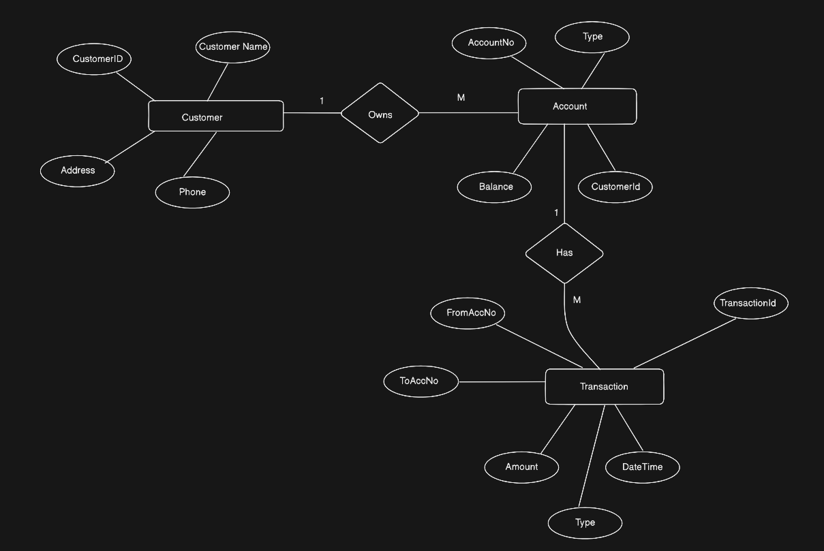

Task 2:
What do you understand by indexing in DBMS? How does it work?
Database indexing is a technique used in DBMS to speed up data retrieval from database.
Database Index helps to quickly locate the record without scanning the entire table
Types of Indexing
- Primary Index
- Created on the primary key
- Each index, points to the data block
- Secondary Index
- Created on non-primary-key attribute
- Used for faster searches on frequently queried columns.

- Clustered Index
- Determines the physical order of a data in a table.
- A table can have only 1 clustered index
- Non-clustered Index
- Stores index separately from actual data
- Contains pointer to data rows
- Each table can have multiple non-clustered index.

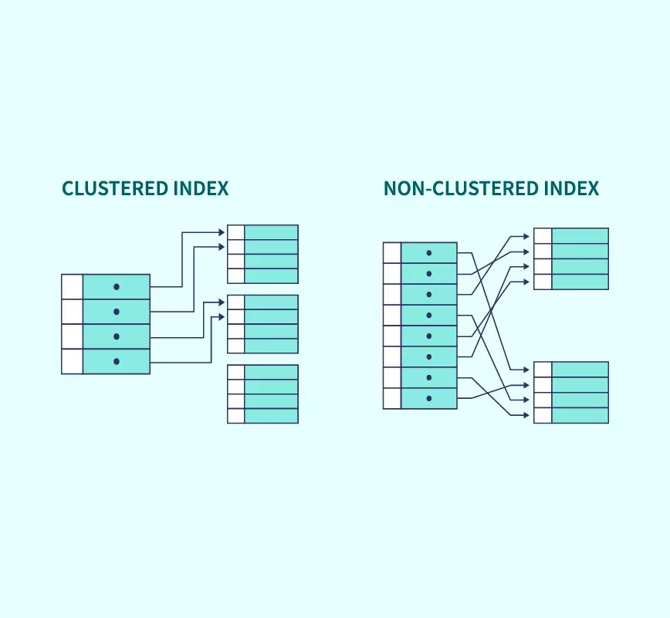

Task 3:
Do you think Indexing strategy improves the query performance ? explain .
Yes, Indexing strategy helps to create a pointer to data blocks directly so data can be fetched directly instead of scanning entire table.

Task 4:
What are the ACID properties in RDBMS? Explain.
• Atomicity: A transaction is completed entirely or not executed at all (all-or-nothing).
• Consistency: A transaction keeps the database in a valid state by following all rules and constraints.
• Isolation: Concurrent transactions execute independently without affecting each other.
• Durability: Once a transaction is committed, its changes are permanently saved even after system failures.

Task 5:
Alter a table to add a column with unique key
ALTER TABLE accounts ADD UNIQUE (id);

Task 6:
Add a check constraint to your column (eg: balance > 0)
ALTER TABLE accounts ADD CHECK (balance > 0);

Task 7:
use where clause and check if it works
select * from Customer where age > 50;

SELECT current_database();

create table accounts(
id serial,
name varchar(10)
);

CREATE INDEX idx_customer_age
ON Customer(age);

ALTER TABLE accounts ADD COLUMN balance DOUBLE PRECISION;

ALTER TABLE accounts ADD CHECK (balance > 0);

ALTER TABLE accounts ADD UNIQUE (id);

INSERT INTO accounts(name,balance) VALUES('yash',400);

ALTER TABLE accounts ADD PRIMARY KEY (id);

ALTER TABLE accounts ADD COLUMN amount DOUBLE PRECISION;

ALTER TABLE accounts RENAME COLUMN "Amount" TO "amount";

select * from accounts;

DELETE FROM accounts WHERE balance IS NULL;

-- TRUNCATE TABLE accounts;

-- DROP TABLE accounts;

CREATE TABLE Customer(
id int primary key,
name varchar(30),
age int,
accountId int references accounts(id)
);

select
CASE
WHEN age < 30 THEN 'YOUNG'
WHEN age >=30 THEN 'OLD'
END as ageCategory from Customer ;

insert into Customer values(101,'Balaji',59,1);

Begin;
insert into Customer values(102,'Balaji',49,1);
insert into Customer values(103,'Balaji',59,1);
Commit;
ROLLBACK;

INSERT INTO Customer VALUES
(104, 'Akshay', 28, 1),
(105, 'Yash', 32, 1),
(106, 'Rahul', 45, 1),
(107, 'Kiran', 25, 1),
(108, 'Anjali', 30, 1),
(109, 'Priya', 27, 1),
(110, 'Vikram', 52, 1),
(111, 'Deepa', 41, 1),
(112, 'Suresh', 65, 1),
(113, 'Megha', 22, 1);

select * from Customer where age > 50;

select * from Customer order by age asc;
select * from Customer order by age asc offset 1 limit 1;

create table frontend_developers (
id int primary key,
name varchar(20),
project_id varchar(20)
);
insert into frontend_developers values (101, 'Ashok', 'P01');
insert into frontend_developers values (102, 'Kishore', 'P02');
insert into frontend_developers values (103, 'Sagar', 'P03');
insert into frontend_developers values (104, 'Hitesh', 'P04');
insert into frontend_developers values (105, 'Hari', 'P44');

select * from frontend_developers;

create table backend_developers (
id int primary key,
name varchar(20),
project_id varchar(20)
);
insert into backend_developers values (111, 'Sam', 'P11');
insert into backend_developers values (122, 'Ritu', 'P22');
insert into backend_developers values (103, 'Sagar', 'P33');
insert into backend_developers values (144, 'Nikky', 'P44');

select * from frontend_developers;
select * from backend_developers;

select * from frontend_developers, backend_developers; -- 20 rec

select * from frontend_developers, backend_developers where frontend_developers.project_id = backend_developers.project_id;

select * from frontend_developers inner join backend_developers on frontend_developers.project_id = backend_developers.project_id;
select * from frontend_developers join backend_developers on frontend_developers.project_id = backend_developers.project_id;

select * from frontend_developers left join backend_developers on frontend_developers.project_id = backend_developers.project_id;

select * from frontend_developers right join backend_developers on frontend_developers.project_id = backend_developers.project_id;

select * from frontend_developers full join backend_developers on frontend_developers.project_id = backend_developers.project_id;

-- Create schema
CREATE SCHEMA hr;

-- Create schema with owner
CREATE SCHEMA AUTHORIZATION alice;

-- Create table in schema
CREATE TABLE hr.employees (
id SERIAL PRIMARY KEY,
name TEXT,
department TEXT
);

-- Drop schema
DROP SCHEMA hr;

-- Drop schema with objects
DROP SCHEMA hr CASCADE;

Connect to spring boot application
package com.dbexample.controller;
import com.dbexample.entity.Customer;
import com.dbexample.service.CustomerService;
import org.springframework.web.bind.annotation.*;
import java.sql.SQLException;
import java.util.Collections;
import java.util.List;
@RestController
@RequestMapping("/customers")
public class CustomerController {
private final CustomerService service;
public CustomerController(CustomerService service) {
this.service = service;
}
@PostMapping
public String addCustomer(@RequestBody Customer customer) {
try {
service.addCustomer(customer);
return "Customer Added";
} catch (SQLException | ClassNotFoundException e) {
return "Error: " + e.getMessage();
}
}
@GetMapping
public List<Customer> getCustomers() {
try {
return service.getCustomers();
} catch (SQLException | ClassNotFoundException e) {
e.printStackTrace();
return Collections.emptyList();
}
}
@GetMapping("/{id}")
public Customer getCustomer(@PathVariable int id) {
try {
return service.getCustomer(id);
} catch (SQLException | ClassNotFoundException e) {
e.printStackTrace();
return null;
}
}
@DeleteMapping("/{id}")
public String deleteCustomer(@PathVariable int id) {
try {
service.deleteCustomer(id);
return "Customer Deleted";
} catch (SQLException | ClassNotFoundException e) {
return "Error: " + e.getMessage();
}
}
}

package com.dbexample.controller;
import com.dbexample.service.CustomerService;
import org.springframework.stereotype.Controller;
import org.springframework.ui.Model;
import org.springframework.web.bind.annotation.GetMapping;
import org.springframework.web.bind.annotation.RequestMapping;
@Controller
@RequestMapping("/thymeleaf")
public class CustomerViewController {
private final CustomerService service;
public CustomerViewController(CustomerService service) {
this.service = service;
}
@GetMapping("/view-customers")
public String viewCustomers(Model model) throws Exception {
model.addAttribute(
"customers",
service.getCustomers()
);
return "customers";
}
}

package com.dbexample.entity;
public class Customer {
private int id;
private String name;
public Customer() {
}
public Customer(int id, String name) {
this.id = id;
this.name = name;
}
public int getId() {
return id;
}
public void setId(int id) {
this.id = id;
}
public String getName() {
return name;
}
public void setName(String name) {
this.name = name;
}
}

package com.dbexample.repository;
import com.dbexample.entity.Customer;
import org.springframework.stereotype.Repository;
import java.sql.*;
import java.util.ArrayList;
import java.util.List;
@Repository
public class CustomerRepository {
// private String driver = "com.mysql.cj.jdbc.Driver";
private String driver = "org.postgresql.Driver";
// private String url = "jdbc:mysql://localhost:3306/customerdb";
private String url = "jdbc:postgresql://localhost:5432/customerdb";
// private String username = "root";
// private String password = "pass123";
private String username = "postgres";
private String password = "pass123";
// CREATE
public void save(Customer customer)
throws ClassNotFoundException, SQLException {
Class.forName(driver);
Connection con =
DriverManager.getConnection(
url,
username,
password);
PreparedStatement ps =
con.prepareStatement(
"INSERT INTO CustomerInfo VALUES(?, ?)");
ps.setInt(1, customer.getId());
ps.setString(2, customer.getName());
ps.executeUpdate();
con.close();
}
// READ ALL
public List<Customer> findAll()
throws ClassNotFoundException, SQLException {
Class.forName(driver);
Connection con =
DriverManager.getConnection(
url,
username,
password);
Statement stmt = con.createStatement();
ResultSet rs =
stmt.executeQuery(
"SELECT * FROM CustomerInfo");
List<Customer> customers =
new ArrayList<>();
while (rs.next()) {
Customer customer =
new Customer();
customer.setId(rs.getInt(1));
customer.setName(rs.getString(2));
customers.add(customer);
}
con.close();
return customers;
}
// READ BY ID
public Customer findById(int id)
throws ClassNotFoundException, SQLException {
Class.forName(driver);
Connection con =
DriverManager.getConnection(
url,
username,
password);
PreparedStatement ps =
con.prepareStatement(
"SELECT * FROM CustomerInfo WHERE id=?");
ps.setInt(1, id);
ResultSet rs = ps.executeQuery();
Customer customer = null;
if (rs.next()) {
customer = new Customer();
customer.setId(rs.getInt(1));
customer.setName(rs.getString(2));
}
con.close();
return customer;
}
// UPDATE
public void update(Customer customer)
throws ClassNotFoundException, SQLException {
Class.forName(driver);
Connection con =
DriverManager.getConnection(
url,
username,
password);
PreparedStatement ps =
con.prepareStatement(
"UPDATE CustomerInfo SET name=? WHERE id=?");
ps.setString(1, customer.getName());
ps.setInt(2, customer.getId());
ps.executeUpdate();
con.close();
}
// DELETE
public void deleteById(int id)
throws ClassNotFoundException, SQLException {
Class.forName(driver);
Connection con =
DriverManager.getConnection(
url,
username,
password);
PreparedStatement ps =
con.prepareStatement(
"DELETE FROM CustomerInfo WHERE id=?");
ps.setInt(1, id);
ps.executeUpdate();
con.close();
}
}

package com.dbexample.service;
import com.dbexample.entity.Customer;
import com.dbexample.repository.CustomerRepository;
import org.springframework.stereotype.Service;
import java.sql.SQLException;
import java.util.List;
@Service
public class CustomerService {
private final CustomerRepository repository;
public CustomerService(CustomerRepository repository) {
this.repository = repository;
}
public void addCustomer(Customer customer) throws SQLException, ClassNotFoundException {
repository.save(customer);
}
public List<Customer> getCustomers() throws SQLException, ClassNotFoundException {
return repository.findAll();
}
public Customer getCustomer(int id) throws SQLException, ClassNotFoundException {
return repository.findById(id);
}
public void deleteCustomer(int id) throws SQLException, ClassNotFoundException {
repository.deleteById(id);
}
}

package com.dbexample;
import org.springframework.boot.SpringApplication;
import org.springframework.boot.autoconfigure.SpringBootApplication;
@SpringBootApplication
public class Main {
public static void main(String[] args) {
SpringApplication.run(
Main.class,
args
);
}
}

